**Chapter 1**

**1.1 INTRODUCTION**

Free Space Optics (FSO) communications, also called Free Space Photonics (FSP) or Optical Wireless, refers to the transmission of modulated visible or infrared (IR) beams through the atmosphere to obtain optical communications. Like fiber, Free Space Optics (FSO) uses lasers to transmit data, but instead of enclosing the data stream in a glass fiber, it is transmitted through the air. Free Space Optics (FSO) works on the same basic principle as Infrared television remote controls, wireless keyboards or wireless Palm devices.

Free-space optical (FSO) communication links are vulnerable to a tremendous amount of variability and offer a real challenge for efficient, robust system design. Fiber-optic communication is a method of transmitting information from one place to another by sending pulses of light through an optical fiber FSO communication system will experience a large dynamic range of performance through most mission scenarios. This communication is basically a line-of-sight (LOS) technology that transmits a modulated beam of visible or infrared light through the atmosphere for broadband communications. Similar to fiber optical communications, free space optics uses a light emitting diode (LED) or laser (light amplification by stimulated emission of radiation) point source for data transmission. However, in free space optics, an energy beam is collimated and transmitted through space rather than being guided through an optical cable[1]. These beams of light, operating in the Terahertz portion of the spectrum, are focused on a receiving lens connected to a high sensitivity receiver through an optical fiber.

**1.2 Definition:**

FSO: optical communication technology that uses light propagating in free space to transfer data.

* Line of sight technology.
* Bandwidth up to 2.5 Gbps.
* Uses LED or Laser as a light source.

**1.3 HISTORY OF FREE SPACE OPTICS (FSO):**

The engineering maturity of Free Space Optics (FSO) is often underestimated, due to a misunderstanding of how long Free Space Optics (FSO) systems have been under development. Historically, Free Space Optics (FSO) or optical wireless communications was first demonstrated by Alexander Graham Bell in the late nineteenth (19th) century (prior to his demonstration of the telephone!). Bell’s Free Space Optics (FSO) experiment converted voice sounds into telephone signals and transmitted them between receivers through free air space along a beam of light for a distance of some 600 feet. Calling his experimental device the “photophone,”

Bell considered this optical technology – and not the telephone – his preeminent invention because it did not require wires for transmission. Although Bell’s photophone never became a commercial reality, it demonstrated the basic principle of optical communications. Essentially all of the engineering of today’s Free Space Optics (FSO) or free space optical communications systems was done over the past 40 years or so, mostly for defense applications. By addressing the principal engineering challenges of Free Space Optics (FSO), this aerospace/defense activity established a strong foundation upon which today’s commercial laser-based Free Space Optics (FSO) systems are based.

**Chapter 2**

**2.1 FSO: WIRELESS, AT THE SPEED OF LIGHT**

**2.1.1 Wireless Communication:**

Wireless communication is the transfer of information between two or more points that are not connected by an electrical conductor.



FIG 2.1.1 Wireless communication technology

Unlike radio and microwave systems, Free Space Optics (FSO) is an optical technology and no spectrum licensing or frequency coordination with other users is required, interference from or to other systems or equipment is not a concern, and the point-to-point laser signal is extremely difficult to intercept, and therefore secure. Data rates comparable to optical fiber transmission can be carried by Free Space Optics (FSO) systems with very low error rates, while the extremely narrow laser beam widths ensure that there is almost no practical limit to the number of separate Free Space Optics (FSO) links that can be installed in a given location.

**2.2 HOW FREE SPACE OPTICS (FSO) WORKS:**

Free Space Optics (FSO) transmits invisible, eye-safe light beams from one "telescope" to another using low power infrared laser in the teraHertz spectrum. The beams of light in Free Space Optics (FSO) systems are transmitted by laser light focused on highly sensitive photon detector receivers. These receivers are telescopic lenses able to collect the photon stream and transmit digital data containing a mix of Internet messages, video images, radio signals or computer files. Commercially available systems offer capacities in the range of 100 Mbps to 2.5 Gbps, and demonstration systems report data rates as high as 160 Gbps.

Free Space Optics (FSO) systems can function over distances of several kilometers. As long as there is a clear line of sight between the source and the destination, and enough transmitter power, Free Space Optics (FSO) communication is possible.

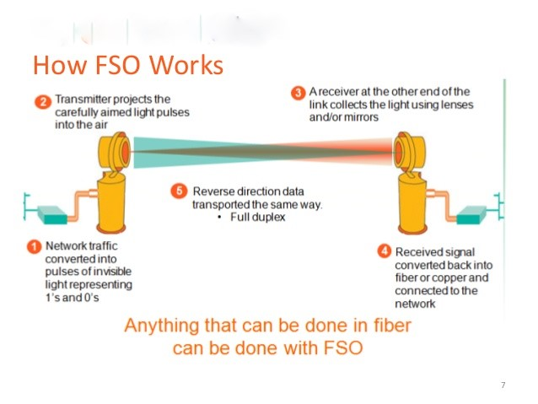

FIG 2.2 Working of free space optics

**Chapter 3**

* 1. **OVERVIEW OF FSO TECHNOLOGY**

**3.1.1 Basic Principal of Free-space optical technology:**

Free-space optical technology uses light, propagating in free space to transmit data between two points. This is useful where the physical connections by the means of fiber optic cable are impractical due to high costs or other considerations. FSO communications or Optical Wireless refers to the transmission of modulated visible or infrared (IR) beams through the atmosphere to obtain optical communications.

In FSO communications, information is transmitted by sending light through optical fibers. The process of communicating using fiber-optics involves the following basic steps: Creating the optical signal involving the use of a transmitter, relaying the signal along the fiber, ensuring that the signal does not become too distorted or weak, receiving the optical signal, and converting it into an electrical signal.

It works in a simple manner. The optical signal is created involving the use of a transmitter, relaying the signal along the fiber, ensuring that the signal does not become too distorted or weak, receiving the optical signal, and converting it into an electrical signal as shown in fig.1[2]. The technology that offers full-duplex Gigabit Ethernet throughput and can be installed license-free worldwide, and can be installed in less than a day. A technology that offers a fast, high ROI. That technology is free-space optics (FSO).This line-of-sight technology approach uses invisible beams of light to provide optical bandwidth connections. It can send up to 1.25 Gbps of data, voice, and video communications simultaneously through the air —that enables fiber-optic connectivity without using physical fiberoptic cable. It enables optical communications at the speed of light.

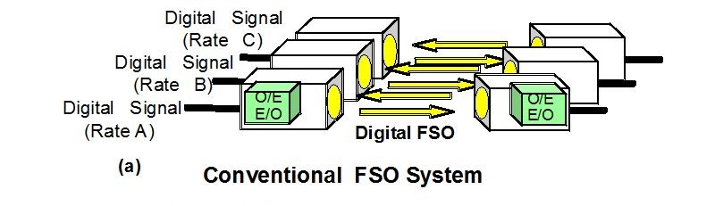

FIG 3.1.1 Conventional FSO System

* + 1. **Next generation FSO systems:**

Next generation FSO system uses light wave at 1550 nm wavelength. In these systems, the technology that is widely used in fiber transmission like ED-FAs and WDM technology is applied. Unlike conventional FSO system, the new FSO system there is no need to convert the signal from electrical to optical and vice versa before transmitting or receiving through free space . Here signal is emitted directly to free space from fibre termination point and at the receiving end focused directly into the fibre core. Loss of the optical signal power caused by space transmission can be compensated by using a fiber amplifier using the same wavelength band of 1550 nm as an optical fiber network.

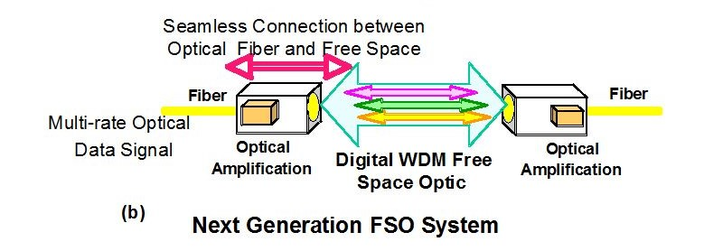

FIG 3.1.2 Next generation FSO System.

* + 1. **Advanced DWDM RoFSO System:**

One attractive application field for the above described full-optical FSO communication system is in an access technology for providing broadband heterogeneous wireless services[3]. As the fiber and free-space optical transmission links carry the same optical signal, the scheme can be utilized as mature technologies and optical components developed for high bit-rate fiber transmission. For example, high-speed data transmission is enabled using 10 Gbps optical sources and receivers or even dense wavelength division multiplexing (DWDM) technology. In present scenario, various kinds of wireless signals such as terrestrial digital TV, 3G cellular signals like WCDMA, WLAN or new innovative wireless services can be transmitted by using DWDM full-optical FSO links. Recently, well developed and experimentally evaluated an advanced DWDM full-optical FSO system link for multiple RF signal transmission.

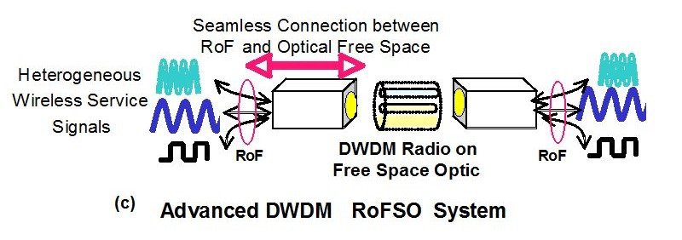

FIG 3.1.3 Advanced DWDM RoFSO System

**Chapter 4**

**4.1 HOW FREE SPACE OPTICS (FSO) CAN HELP YOU**

FSO’s freedom from licensing and regulation translates into ease, speed and low cost of deployment. Since Free Space Optics (FSO) transceivers can transmit and receive through windows, it is possible to mount Free Space Optics (FSO) systems inside buildings, reducing the need to compete for roof space, simplifying wiring and cabling, and permitting Free Space Optics (FSO) equipment to operate in a very favorable environment. The only essential requirement for Free Space Optics (FSO) or optical wireless transmission is line of sight between the two ends of the link.

For Metro Area Network (MAN) providers the last mile or even feet can be the most daunting. Free Space Optics (FSO) networks can close this gap and allow new customer’s access to high-speed MAN’s. Providers also can take advantage of the reduced risk of installing a Free Space Optics (FSO) network which can later be redeployed.

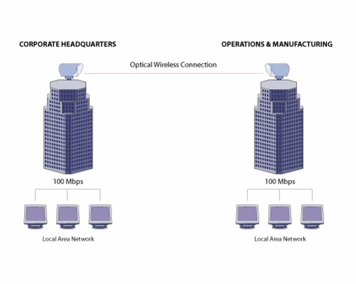

FIG 4.1 Operation of FSO

**4.2 WHY FSO?**

The increasing demand for high bandwidth in metro networks is relentless, and service providers' pursuit of a range of applications, including metro network extension, enterprise LAN-to-LAN connectivity, wireless backhaul and LMDS supplement has created an imbalance. This imbalance is often referred to as the "last mile bottleneck." Service providers are faced with the need to turn up services quickly and cost-effectively at a time when capital expenditures are constrained. But the last mile bottleneck is only part of a larger problem. Similar issues exist in other parts of the metro networks. "Connectivity bottleneck "better addresses the core dilemma. As any network planner will tell you, the connectivity bottleneck is everywhere in metro networks.

The first, most obvious choice is fiber-optic cable. Without a doubt, fiber is the most reliable means of providing optical communications. But the digging, delays and associated costs to lay fiber often make it economically prohibitive. Moreover, once fiber is deployed, it becomes a "sunk" cost and cannot be re-deployed if a customer relocates or switches to a competing service provider, making it extremely difficult to recover the investment in a reasonable timeframe.

Another option is radio frequency (RF) technology. RF is a mature technology that offers longer ranges distances than FSO, but RF-based networks require immense capital investments to acquire spectrum license. Yet, RF technologies cannot scale to optical capacities of 2.5 gigabits. The current RF bandwidth ceiling is 622 megabits. When compared to FSO, RF does not make economic sense for service providers looking to extend optical networks.

The third alternative is wire- and copper-based technologies, (i.e. cable modem, T1s or DSL). Although copper infrastructure is available almost everywhere and the percentage of buildings connected to copper is much higher than fiber, it is still not a viable alternative for solving the connectivity bottleneck. The biggest hurdle is bandwidth scalability. Copper technologies may ease some short-term pain, but the bandwidth limitations of 2 megabits to 3 megabits make them a marginal solution, even on a good day.

**Chapter 5**

**5.1 ARCHITECTURE OF FREE SPACE OPTIC(FSO)TECHNOLOGY**

Three main FSO architectures are:

* + 1. Point-to-point architecture is a dedicated connection that offers higher bandwidth but is less scalable.

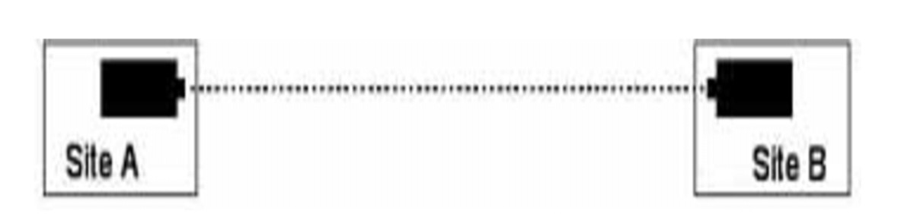

FIG 5.1.1 Point-to-point architecture

* + 1. Mesh architectures may offer redundancy and higher reliability with easy node addition but restrict distances more than the other options.

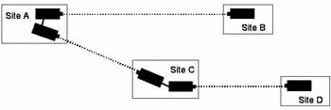

FIG 5.1.2 Mesh architecture

* + 1. Point-to-multipoint architecture offers cheaper connections and facilitates node addition but at the expense of lower bandwidth than the point-to-point option.

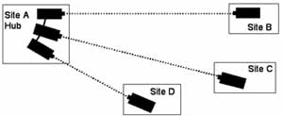

FIG 5.1.2 Point-to-multipoint architecture

**Chapter 6**

**6.1 OPERATIONAL TERMINAL OF FREE SPACE OPTICS.**

In space communications, FSO links are considered the ultimate media to establish high bit-rate data links between satellites. They use diffraction-limited laser beams with large-aperture optics (telescopes) and require accurate pointing and tracking technology. It can be used for link distances of up to 1km. A refractive telescope with an effective aperture of 2.4cm is used as an optical antenna to collect the incoming laser beam and convert it into a thin, collimated beam with an internal diameter of 2mm. A fast-steering mirror (FSM) is placed at the telescope's exit pupil to stabilize the angle-of-arrival (AOA) fluctuations of the free-space laser beam. (The latter are caused by vibrations and/or thermal deformations of the terminal support structures and by atmospheric turbulence in the propagation path.) The stabilized beam is focused into the SMF at the fiber coupler. A tracking sensor using a silicon-quadrant photo detector is integrated into the fiber coupler to detect AOA fluctuations and alignment errors. Based on the horizontal and vertical error signals, an analog proportional-integral-differential servo controller with a bandwidth of >5kHz drives the FSM. After SMF coupling, an optical circulator is used to separate incoming and transmitting optical signals. A near-IR beacon is used for bidirectional tracking.The wavelengths of 972 and 982nm, both within the EDFA's pump-laser band, for operational tests. The transmitting signal and beacon laser light are multiplexed by a wave-division-multiplexing (WDM) coupler and then transmitted to the opposite terminal using the same optical path as the signal light, i.e., through the fiber coupler, the FSM, and the optical antenna.

The overall optical-signal attenuation from the optical aperture to the SMF connector is approximately 2.0dB. The terminal size is 12×12×20cm3, and its total weight is less than 1kg (see Figure 2 for an internal view). The electrical power required for terminal operation including FSM servo and beacon-laser driver is less.

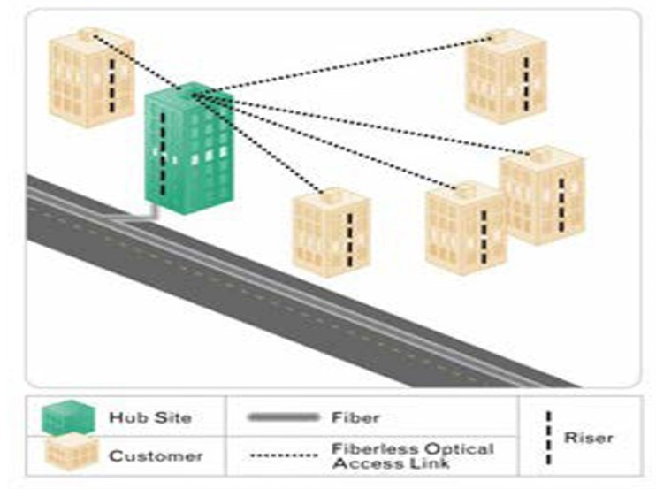

FIG 6.1 Operational Terminal of Free Space Optics.

**6.2 Construction of an FSO Data link:**

**6.2.1 FSO Transmitter and Receiver:**

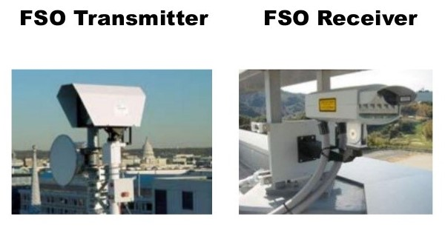

FIG 6.2 FSO Transmitter and Receiver:

In general, an FSO link consists of an optical signal transmitter and a receiver. As shown in Fig. 6.2, the transmitter is used to transmit data signals in free space by modulation of optical radiation. Its main elements are a radiation source, a laser modulator and optical devices.

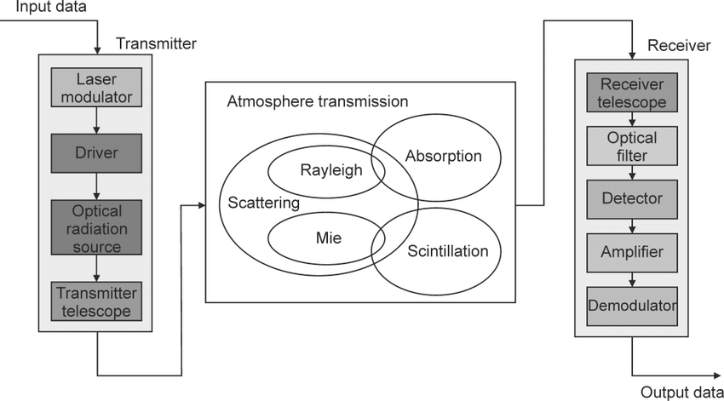

FIG 6.3 Construction of an FSO data link

The laser modulator modulates the optical signal with an electrical one by varying e.g. the laser biasing current. The most popular optical device is a telescope. It is applied to direct optical radiation towards the receiver.

**Chapter 7**

**7.1 ADVANTAGES OF FSO TECHNOLOGY**

1. FSO communications can provide flexible, easy-to-install, and license-free line-of-sight wireless communications links. The high speed and large bandwidth offered by light-wave communication technology make them very attractive as means to meet future demand for broadband Internet access and high definition television broadcasting services. However, the bit rate of existing FSO links using near-IR lasers in the 780–850nm range is still limited to 1–2.5 GB/s. This is due to both the upper limit to laser power usually adopted to maintain eye safe light levels and the lack of existing high-speed optical devices required to build multi-gigabit optical terminals.
2. Longer-wavelength spectral regimes, such as the 1.5μm band, have maximum permissible exposures that are less critical than that for the 780–850nm range.
3. They are also attractive because of the wide variety of existing optical devices suitable for multi-gigabit operation. Particularly, erbium-doped fiber amplifiers (EDFAs), which can be engineered for operation at longer wavelengths, are among the most important elements in high-power transmitters and sensitive receivers. To use EDFAs as high-speed optical devices, we must efficiently couple a stable free space optical beam to a single-mode fiber (SMF)—characterized by a mode-field diameter of approximately 10μm—because almost all high-speed fiber-optic components are connected by SMFs.
4. Lower costs as compared to fiber networks, easiness and speed of installation, high transmission capacity, network protocol transparency, right-of-way free, license-free installation, license-free frequency band, low risk investment, fast revenue generation etc. FSO costs are as low as 1/5 of fiber network costs while installation takes no longer than 2 to 3 days (fiber may demand 6 to 12 months of work).

**7.2 MAJOR CHALLENGES:**

1. Atmospheric Attenuation-FOG

* Absorption or scattering of optical signals due to airborne particles
* Primarily FOG but can be rain, snow, smoke, dust, etc.
* Can result in a complete outage
* FSO wavelengths and fog droplets are close to equal in size (Mie Scattering)
* Typical FSO systems work 2-3X further than the human eye can see
* High availability deployments require short links that can operate in the fog

1. Low Clouds, Rain, Snow and Dust

* Low Clouds
* Very similar to fog
* May accompany rain and snow
* Rain
* Drop sizes larger than fog and wavelength of light
* Extremely heavy rain (can’t see through it) can take a link down

1. Scintillation

* Beam spreading and wandering due to propagation through air pockets of varying temperature, density, and index of refraction.
* Almost mutually exclusive with fog attenuation.

**7.3 APPLICATIONS**

Two solar- powered satellites communicating optically in space via lasers.

Typically scenarios for use are:

* 1. LAN-to-LAN connections on campuses at Fast Ethernet or Gigabit Ethernet speeds.
  2. LAN-to-LAN connections in a city. example, Metropolitan area network.
  3. To cross a public road or other barriers which the sender and receiver do not own.
  4. Speedy service delivery of high-bandwidth access to optical fiber networks.
  5. Converged Voice-Data-Connection.
  6. Temporary network installation (for events or other purposes).
  7. Reestablish high-speed connection quickly (disaster recovery).
  8. As an alternative or upgrade add-on to existing wireless technologies.
  9. As a safety add-on for important fiber connections (redundancy).
  10. For communications between spacecraft, including elements of a satellite constellation.
  11. For inter- and intra-chip communication.

**Chapter 8**

**CONCLUSION:**

In FSO links, atmospheric turbulence causes fluctuations in both the intensity and the phase of the received light signal, impairing link performance. Mesh configurations generally provide shorter link distances between network elements, along with it also provide path diversity, which enhances link reliability in face of inclement weather and temporary obstructions. The potential for Free-space optical networking to solve communications bottlenecks is making it a popular option for reliable, broadband access. With the efficient infrastructure access points, opportunities for short hop wireless connectivity in wireless communication technology. It is believed that FSO links and hybrid RF/FSO links are well suited for next generation cellular topology models including mesh networks. A thorough examination of the issues affecting the design of these sophisticated systems is a useful tool when evaluating Free Space Optics (FSO) systems for purchase. Systems that incorporate the most beneficial features, are well engineered, and thoroughly tested will be top performers and provide the best value.

**REFERENCES:**

1. Chaudhary, Laxmi, Sudha Yadav, and Rohit Mathur. "Next generation free space optics system in wireless communication technology." *International Journal of Advances in Electrical and Electronics Engineering (IJAEEE, ISSN: 2319-1112)* 1.02 (2012): 255-261.
2. Willebrand, Heinz, and Baksheesh S. Ghuman. *Free space optics: enabling optical connectivity in today's networks*. SAMS publishing, 2002.
3. M. A. Khalighi and M. Uysal, "Survey on Free Space Optical Communication: A Communication Theory Perspective," in IEEE Communications Surveys & Tutorials, vol. 16, no. 4, pp. 2231-2258, Fourthquarter 2014.
4. Chan, Vincent WS. "Free-space optical communications." *Journal of Lightwave technology* 24.12 (2006): 4750-4762.
5. Komine, Toshihiko, and Masao Nakagawa. "Fundamental analysis for visible-light communication system using LED lights." *IEEE transactions on Consumer Electronics* 50.1 (2004): 100-107.
6. Cvijetic N. OFDM for next-generation optical access networks. Journal of lightwave technology. 2011 Aug 29;30(4):384-98.
7. Murugan, KH Shakthi, and M. Sumathi. "Design and Analysis of 5G Optical Communication System for Various Filtering Operations using Wireless Optical Transmission." *Results in Physics* 12 (2019): 460-468.
8. D. M. Jeganathan and D. P. Ionov. (2001, Dec 27). Multi-Gigabitsper- second optical wireless communications [Online]. Available: [www.freespaceoptic.com](http://www.freespaceoptic.com)